Linux Performance Issues:
In modern systems - especially embedded, automotive, or enterprise servers — performance plays a vital role. The Linux kernel provides a highly flexible and feature-rich environment, but if not optimized properly, it can lead to long boot times, high CPU usage, memory bloat, or slow I/O performance.
Performance issues are not just about speed , they’re about efficiency, responsiveness, and scalability. They determine how well a system utilizes CPU, memory, storage, and network resources.
So, the goal of performance analysis and optimization is to identify bottlenecks(the parts of the system that limit overall performance or slow down execution), eliminate unnecessary overhead, and fine-tune the kernel and user-space components to achieve maximum throughput with minimum latency.
For this project, we focused on two main aspects:
1️ Optimization of Boot Time on Linux Kernel (version 6.13)
2️ Optimization of Memory Usage on Linux Kernel (version 6.13)
Both of these are critical in embedded and real-time systems where every millisecond and every kilobyte of RAM matters.

Understanding Linux Performance
Performance in Linux is influenced by many subsystems — the CPU scheduler, memory management, file systems, device drivers, and even the init process.
At a high level, Linux performance tuning involves:
- Reducing boot time (how fast the system starts).
- Minimizing memory footprint (how much RAM is consumed).
- Optimizing CPU scheduling and interrupt latency.
- Improving I/O throughput and context switching efficiency.
- Analyzing system calls, daemons, and kernel threads to eliminate waste.
In embedded devices or IoT systems, these optimizations directly affect battery life, real-time responsiveness, and thermal management.

Project 1 - Optimization of Boot Time on Linux Kernel (v6.13)
Let’s first discuss boot time optimization.
The boot process in Linux typically includes multiple stages — bootloader (like U-Boot or GRUB), kernel initialization, root filesystem mounting, and userspace startup via systemd or init.
By default, these steps can take several seconds — sometimes more on slower embedded hardware. But for real-time or consumer devices like smart TVs, routers, or automotive systems, the boot time target is often less than 2 or 3 seconds.
To achieve this, we analyze and optimize every stage of the boot process:"

Step-by-Step Boot Optimization Approach
Bootloader Optimization:
- We reduce delays in U-Boot by disabling unnecessary boot menus or countdowns.
- Configure U-Boot to directly load the kernel image (zImage or Image.gz) from flash into memory without user input.
- Use compressed but fast-decompressing formats.
Kernel Optimization:
- Rebuild the kernel with only required drivers and features using make menuconfig and defconfig.
- When you build the Linux kernel yourself, you can choose which features, drivers, and modules to include.

Key Tools
Command | Purpose
make defconfig | Loads a default (baseline) configuration for your hardware or architecture
make menuconfig | Opens an interactive menu where you can enable/disable kernel features

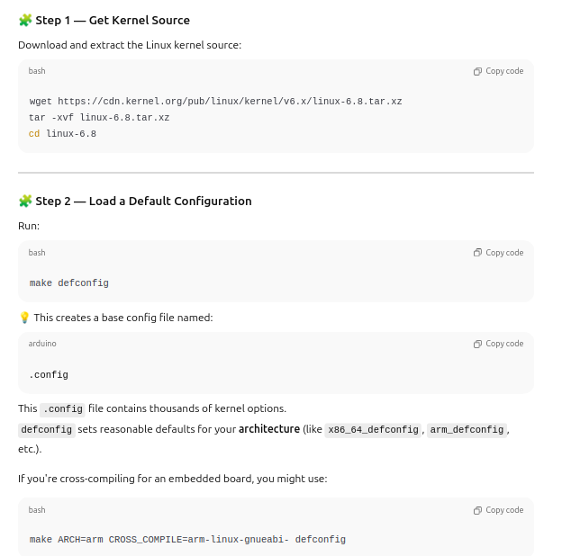
Then the build system checks your host machine and automatically sets:
- ARCH = x86_64 (if you’re on a typical desktop or laptop)

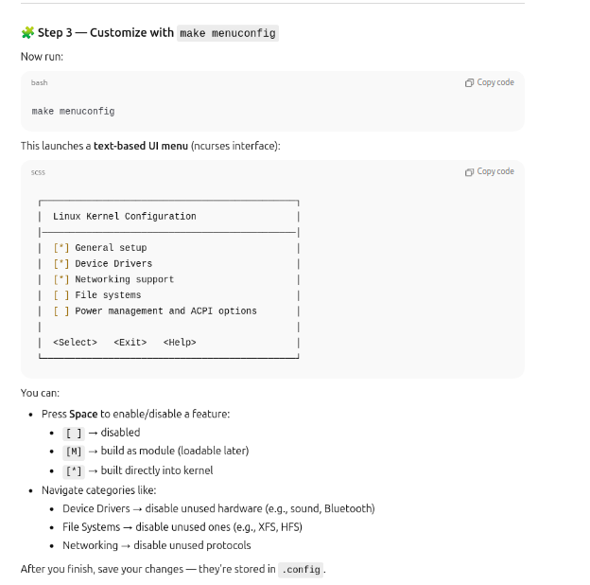

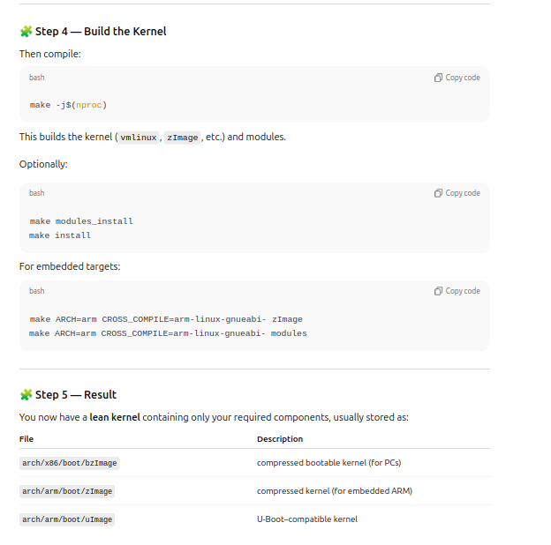
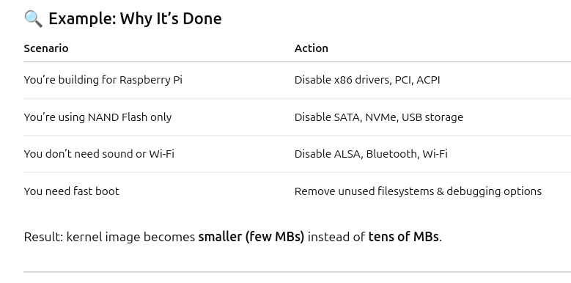
- make defconfig loads a default kernel configuration for your CPU/board.
- It enables a standard set of drivers and features that work for most systems.
- It does not include all drivers, only common ones.
- make menuconfig opens an interactive text menu for customization.
- You can enable/disable drivers, filesystems, and kernel features there.
- This helps build a custom kernel with only what your hardware needs.
- Fewer drivers → smaller kernel size and faster boot time.
- Common workflow: make defconfig → make menuconfig → make.
- Used heavily in embedded systems and boot-time optimization.
- Goal: keep only required modules, remove everything unnecessary. ✅

We use both because:
- make defconfig gives you a working baseline configuration.
- make menuconfig lets you customize that baseline (add/remove drivers or features).
So:
🧠 make defconfig = start point
🧠 make menuconfig = modify it for your needs

Step-by-Step Reason
Kernel has thousands of options — starting from scratch is impossible.
make defconfig loads a ready-made default config for your architecture (e.g., x86, ARM).
The Kernel Source Has Separate Folders for Each Architecture
Inside the kernel source tree, you’ll see:
arch/
├── arm/
├── arm64/
├── x86/
├── mips/
├── riscv/
└── powerpc/
Each of these contains:
Architecture-specific code
A default configuration file, e.g. defconfig
Platform-specific Makefiles
So the kernel already knows about multiple CPU architectures.

2. How make Chooses the Architecture
When you run:
make defconfig
the build system checks the ARCH variable.

🧠 Case 1: You Don’t Specify ARCH
If you run make defconfig on your own PC (like x86_64):
The kernel build system detects your architecture automatically from your compiler and host system.
It sets:
ARCH = x86
so it loads
arch/x86/configs/defconfig
That’s how it knows your system is x86.
Now you have a file .config with sane defaults.
Then, you run make menuconfig to open that .config in an interactive menu.
You can now disable unused drivers, enable special ones, or tweak options.
Finally, make builds the kernel using your updated .config.

- Disable unnecessary modules, debug options, and tracing features.
- Use CONFIG_INITRAMFS_SOURCE to embed a small root filesystem directly into the kernel to eliminate initrd mounting delay.
- Enable parallel initialization of device drivers using initcall_debug and initcall_parallel.
Root Filesystem Optimization:
- Use a minimal filesystem (like BusyBox) instead of full distributions.
- Remove unused daemons and services from /etc/init.d/ or systemd.
- Compress the filesystem with SquashFS or ext4 with minimal journaling.
Systemd Analysis:
- Use the systemd-analyze command to measure time spent in kernel and userspace boot phases.
Run systemd-analyze blame to identify the slowest services and optimize or disable them.

Systemd Boot Time Analysis — Explained for Optimization

🧩 1. What Happens During Boot
The Linux boot process has two major parts:
- Kernel phase → from power-on to when the kernel hands control to userspace.
- Userspace phase → when systemd starts all services (network, GUI, daemons, etc.).
To optimize boot time, you need to measure and identify delays in both phases.
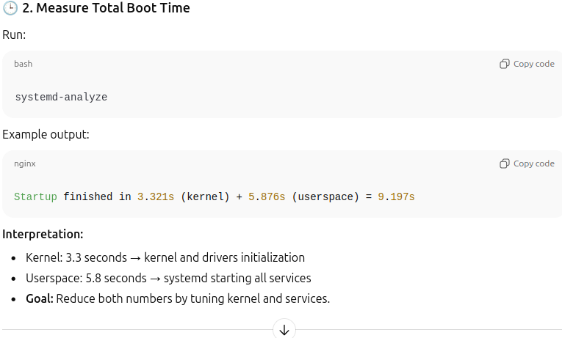
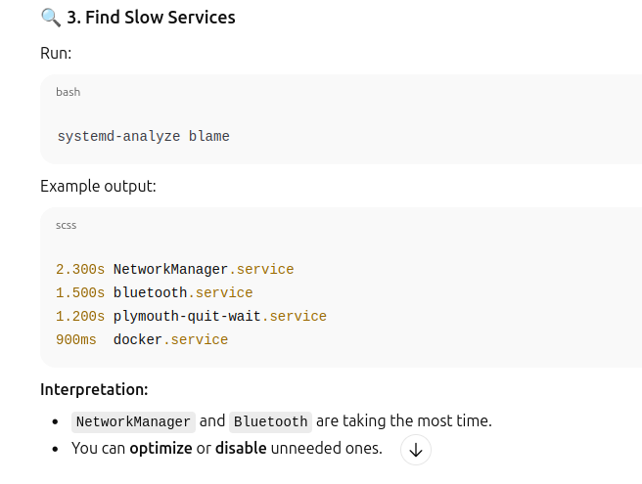
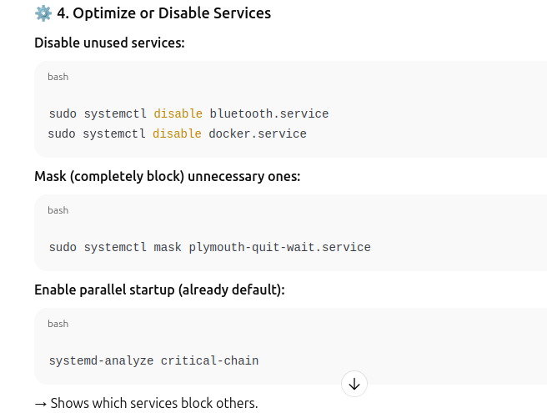

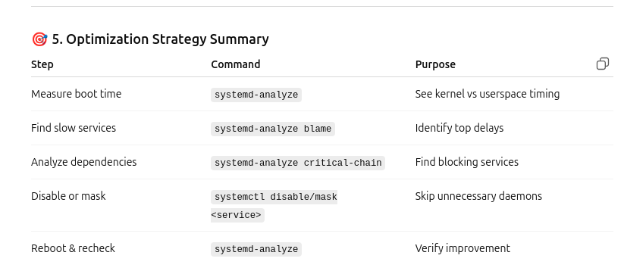
Hardware and Driver Initialization:
- Use deferred probing to prevent blocking init calls.
- Load drivers asynchronously.
- Optimize firmware loading by keeping firmware binaries in pre-mounted locations.

1. Deferred probing
What it is: Some drivers require other hardware or buses to be ready first. Deferred probing delays their initialization instead of blocking the boot.
Example: A USB storage driver depends on the USB controller. If the controller isn’t ready yet, deferred probing allows the driver to wait without stopping the boot process.

Deferred Probing Explained
- Problem without deferred probing:
Suppose a USB storage driver tries to initialize before the USB controller is ready. Normally, the driver will fail or block the boot, making the system wait unnecessarily.
- Deferred probing solution:
The kernel doesn’t fail immediately. Instead, it says “I’ll try again later” once the required hardware is ready. This way, boot can continue without being blocked.
- Example:
  - System starts booting. USB controller isn’t ready yet.
  - USB storage driver initializes → sees controller isn’t ready → deferred probing kicks in.
  - Boot continues loading other services.
  - Later, USB controller becomes ready → kernel automatically retries initializing the USB storage driver.
✅ Key point: Deferred probing avoids stalling the boot due to hardware dependencies.
static int usb_storage_probe(struct usb_interface *interface,
const struct usb_device_id *id)
{
struct usb_device *udev = interface_to_usbdev(interface);

// Check if USB controller is ready
if (!usb_controller_ready(udev)) {
// Dependency not ready, defer probe
printk(KERN_INFO "usb_storage: deferring probe\n");
return -EPROBE_DEFER; // Kernel will retry later
}

// Initialize driver normally
printk(KERN_INFO "usb_storage: driver initialized\n");
return 0;
}

How It Works
- Kernel tries to probe the USB storage driver at boot.
- If USB controller isn’t ready:
  - Driver returns -EPROBE_DEFER.
  - Kernel re-queues this driver to probe later.
- Once USB controller is ready, kernel retries probe.
- Driver initializes successfully without blocking boot.

Key Points
- No need to manually wait for dependencies.
- Improves boot time because other drivers continue loading.
- Most modern drivers already support this automatically.

2. Asynchronous driver loading
What it is: Drivers are loaded in parallel rather than one by one, reducing overall boot time.
Example: The network driver, graphics driver, and sound driver can initialize at the same time instead of waiting for each other sequentially.

Scenario:
You have a system with these drivers:
- USB Controller Driver (depends on PCI bus)
- Audio Driver (independent)
- Network Driver (independent)

Synchronous Loading (default without async probe)
Step | Driver | Status
1 | USB Controller | Initializing… wait until done
2 | Audio | Waiting for step 1 to finish
3 | Network | Waiting for step 1 to finish

CONFIG_ASYNC_PROBE=y

3. Optimized firmware loading
What it is: Keep firmware files ready in pre-mounted directories so drivers can load them quickly.
Example: The Wi-Fi driver needs a firmware file (iwlwifi-*.ucode). If it’s already in /lib/firmware, the kernel loads it immediately instead of searching or downloading it, speeding up the boot.
- ✅ In short: Deferred probing avoids blocking, async loading runs drivers in parallel, and preloaded firmware ensures drivers get what they need immediately. All together, these reduce boot time significantly.

2. What “Optimized Firmware Loading” means
Goal: Make sure the required firmware files are immediately available when the driver loads.

Normally (unoptimized):
- The kernel probes a driver (e.g., Wi-Fi).
- The driver requests its firmware.
- The system searches /lib/firmware, waits for user space (like udev) to mount /usr or /lib, or even times out.
- Only then can the driver initialize.
→ This causes delays and blocking during boot.

With Optimized Firmware Loading:
- The firmware files are already present and accessible (for example, in /lib/firmware on the root filesystem, which is mounted early).
- When the driver requests firmware, it is loaded instantly.
- The driver initializes immediately — no waiting for mounts, udev, or network access.

Why the driver requests firmware
When the Linux kernel boots and detects a device, it loads the appropriate driver module.
That driver might not have the device’s internal firmware baked into it (for licensing or size reasons).
So the driver must request it from the filesystem.

Measurement Tools:
- Use ftrace, bootchart, and initcall_debug to measure per-module initialization times.
- Log boot messages using dmesg timestamps to identify slow stages.
By following this structured approach, we can significantly reduce total boot time from, say, 8 seconds to 3 seconds or less — depending on the hardware and features enabled."

Tools Used in Boot Time Optimization
- meminfo → To observe memory usage during boot.
- rootfs → To create and optimize minimal filesystem images.
- ftrace and initcall_debug → To trace driver initialization latency.
- systemd-analyze → For detailed boot phase breakdown.
- strace → To monitor system call delays during initialization.

Project 2 -Optimization of Memory Usage on Linux Kernel (v6.13)
Now let’s talk about memory optimization - another major part of performance improvement.
Memory is one of the most critical resources in any system. In embedded Linux, where devices may have only 128MB or 256MB RAM, every byte counts.
The Linux kernel dynamically allocates and frees memory for different purposes — page cache, process heap, kernel stacks, file buffers, and slab caches. However, poorly written drivers or excessive kernel options can lead to fragmentation, leaks, or overcommitment, causing the system to slow down or crash."
- Poorly written drivers:
  - Drivers are programs that help the OS talk to hardware.
  - If they are buggy or inefficient, they may use memory incorrectly or block resources.
- Excessive kernel options:
  - When you compile the kernel with too many unnecessary features or drivers, it increases complexity and resource usage.
- Fragmentation:
  - Memory gets divided into small unusable pieces over time, making allocation slower.
- Leaks (Memory Leaks):
  - The kernel or drivers may allocate memory and never free it, reducing available memory gradually.
- Overcommitment:
  - System promises more resources (CPU, memory) than physically available → can slow down or crash under load.
- Result:
  - Boot becomes slower, services may hang, system may become unstable or even crash.
In short: Adding unnecessary kernel options or having bad drivers can waste memory/resources and hurt system performance.

Steps to Optimize Memory Usage
1️ Analyze Memory Layout:
- Use /proc/meminfo, /proc/slabinfo, and /proc/vmstat to understand where memory is consumed.
- Identify memory-hungry components such as slab caches or page caches.

1. Analyze Memory Layout
When optimizing memory, you first need to know how memory is being used. Linux provides virtual files under /proc that give detailed info:
- /proc/meminfo
  - Shows overall memory usage, including total/free memory, buffers, cached data, swap, etc.
  - Example output snippet:
MemTotal: 16384256 kB
MemFree: 1234567 kB
Buffers: 567890 kB
Cached: 2345678 kB
Use: See how much memory is free and how much is used by caches/buffers.
- /proc/slabinfo

Why Kernel Objects Matter
- The kernel keeps thousands of these small objects in memory.
- They are stored in caches (like dentry_cache, inode_cache, buffer_head_cache).
- Tools like slabtop or /proc/slabinfo show memory used by these objects.
  - Shows memory used by the kernel’s internal caches (slabs).
  - Slabs are used to store kernel objects efficiently.
  - Example: If dentry_cache is very high, it means a lot of memory is consumed storing directory entries.
  - Use: Identify which kernel structures are taking the most memory.
- /proc/vmstat
  - Provides detailed virtual memory statistics, like page faults, swaps, and cache activity.
  - Use: Helps understand if memory pressure is causing frequent swapping or cache flushing.
nr_free_pages 12345
nr_inactive_anon 5678
nr_active_anon 91011
nr_inactive_file 1213
nr_active_file 1415
pgfault 23456
pgmajfault 123
pswpin 45
pswpout 67
pgpgin 890
pgpgout 678

2. Identify Memory-Hungry Components
- After analyzing the above, you can see which parts are using the most memory:
  - Slab caches (kernel objects)
  - Page caches (files cached in RAM)
  - Buffers (I/O related)
- Goal: Target optimization on heavy consumers, e.g., reduce unnecessary slab objects or tune cache sizes.
Summary:
Use /proc/meminfo, /proc/slabinfo, and /proc/vmstat to get a snapshot of memory usage, then focus on the biggest consumers for optimization.
2️ Disable Unused Kernel Features:
- Rebuild the kernel with only necessary modules.
- Disable debugging symbols (CONFIG_DEBUG_KERNEL) unless required.
- Remove large, unused subsystems like sound, networking, or filesystems that are not needed.
3️ Optimize Slab Allocator and Caches:
- Use slabtop to monitor kernel object caches in real time.
- Adjust kernel parameters for cache shrinking or aggressive page reclaim.
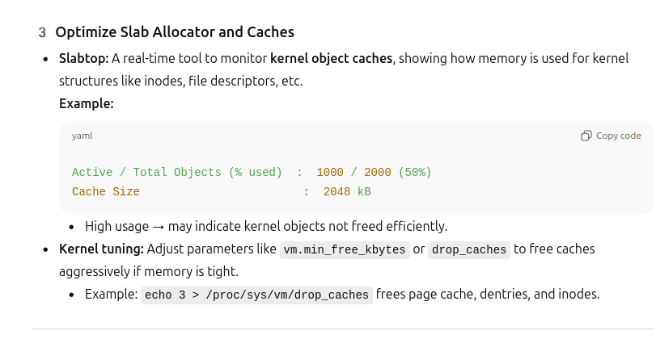

1. What are Page Cache, Dentries, and Inodes?
- Page Cache
  - Stores actual file contents that the system has read from disk.
  - Example: If you open a big text file, Linux keeps it in memory so next time it’s fast.
- Dentries (Directory Entries)
  - Store directory and file name information.
  - Example: When you access /home/user/file.txt, the system remembers the path and file names to avoid repeated lookups.
- Inodes
  - Store metadata about files (size, permissions, timestamps, etc.) but not file content.
Think of it like a library:
- Page Cache = the books on the reading table (contents).
- Dentries = the catalog cards (file names and locations).
- Inodes = book information (author, pages, publish date).

2. When do we use drop_caches?
- Free memory temporarily without rebooting.
- Examples:
  - On embedded systems with limited RAM.
  - When testing performance after cache changes.
  - To release memory after heavy file operations or large data processing.
Important: It doesn’t harm running processes but may slow down disk reads because the cached data is gone.

3. How to use selectively
- Free only page cache if you want to release file contents:
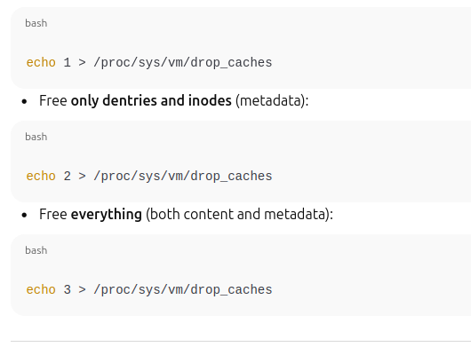

4️ Use Memory Leak Detection Tools:
- kmemleak — A kernel-based leak detector that tracks all allocated and freed memory objects.
- valgrind — A user-space memory debugging tool that detects leaks and invalid accesses.
5️ Optimize Page Cache and Swapping:

1. Swappiness (/proc/sys/vm/swappiness)
- What it is:
Controls how likely the kernel is to move inactive pages from RAM to swap space (disk).
- Values:
  - 0 → Kernel avoids swapping as much as possible.
  - 100 → Kernel swaps aggressively to free RAM.
  - Default is usually 60.
- Example:
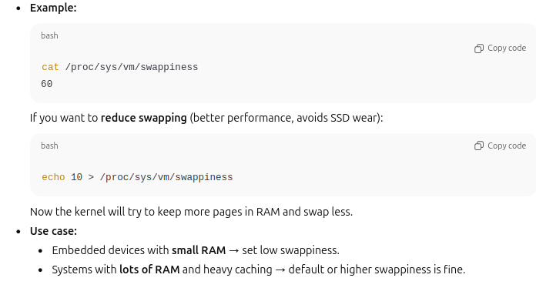

2. Dirty Ratio (/proc/sys/vm/dirty_ratio)
- What it is:
Limits the maximum percentage of total RAM that can be “dirty” (modified but not yet written to disk).
- Why it matters:
  - Too high → lots of data waits in RAM → sudden disk flush can freeze the system.
  - Too low → frequent small writes → disk I/O overhead.
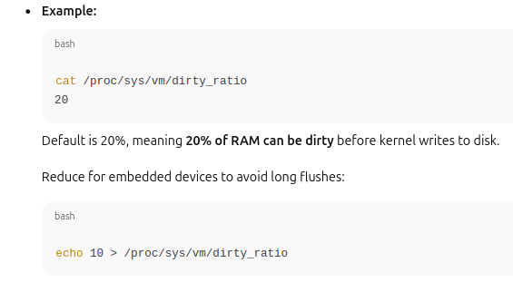

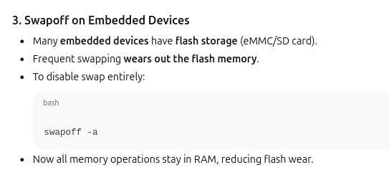

Tune /proc/sys/vm/swappiness and /proc/sys/vm/dirty_ratio to control caching behavior.
- Disable swap if not needed in embedded devices to reduce wear on flash memory.
6️ Analyze with Performance Profilers:
- Use perf, top, and htop to identify processes consuming excessive memory.
- Enable CONFIG_PROC_PAGE_MONITOR to observe per-process memory stats.

6️ Analyze with Performance Profilers
- perf: Profiles CPU and memory usage of processes and kernel events.
  - Example: perf top → shows functions consuming most CPU/memory.
- top / htop: Shows memory usage per process.
  - Quickly identifies memory-hungry processes.
- CONFIG_PROC_PAGE_MONITOR: Kernel config option to get per-process memory stats in /proc.
  - Helps track which processes consume most kernel and user memory.

Tools Used in Memory Optimization
- meminfo — To view system-wide memory distribution.
- slabtop — To monitor kernel memory caches.
- kmemleak — To detect and trace memory leaks inside kernel.
- valgrind — For user-space leak detection.
- free, top, vmstat — For runtime monitoring of memory and CPU usage.

5. Real-World Impact and Importance
"Performance tuning in Linux directly affects the user experience, power efficiency, and stability of devices.
For example, in an embedded automotive system, boot time optimization ensures that critical dashboards or infotainment systems are available within seconds after ignition.
Similarly, memory optimization ensures that long-running systems do not degrade over time due to fragmentation or leaks.
In servers, reducing memory and CPU load can increase the number of concurrent clients served, while in IoT gateways, it can help keep devices responsive and power-efficient.
Thus, analyzing and optimizing Linux performance is not just a debugging exercise — it’s a key part of system design."

6. Summary
"To summarize:
- Linux performance issues arise from inefficiencies in kernel configuration, resource allocation, or initialization sequences.
- Boot time optimization focuses on speeding up startup by minimizing hardware and software delays.
- Memory optimization focuses on reducing runtime memory footprint and preventing leaks.
- Tools like meminfo, rootfs, ftrace, kmemleak, and valgrind help engineers systematically measure and fix bottlenecks.
By mastering these techniques, developers can build Linux systems that are not only functional — but fast, stable, and efficient.

